Fayol Inc. 0547824419
SECOND TERM
WEEKLY LESSON NOTES
WEEK 5
Week Ending: |  | DAY: |  | Subject: Mathematics
Duration: 60MINS |  |  |  | Strand: Algebra
Class: B9 |  | Class Size: |  | Sub Strand: Algebraic Expressions
Content Standard:  B9.2.2.1 Demonstrate an understanding of (i) change of subject (ii) substituting values to evaluate expressions, and (iii) factorize expressions that have simple binomial as a factor |  |  | Indicator:  B9.2.2.1.1 Perform change of subject of a given formula and use it to solve problems. |  |  |  | Lesson:  1 of 1
Performance Indicator:  Learners can perform algebraic manipulations to isolate the desired variable and apply formula manipulation to solve problems in various contexts |  |  |  |  | Core Competencies:  Communication and Collaboration (CC) Critical Thinking and Problem solving (CP)
References: Mathematics Curriculum Pg. 184
New words: formula, substituting, factorize, manipulations
Phase/Duration | Learners Activities |  |  |  |  | Resources
PHASE 1: STARTER | Begin by reviewing familiar formulas learners encounter in everyday life (e.g., area of a rectangle, perimeter of a triangle).  Ask them to identify the variables involved and discuss why manipulating formulas might be useful.  Share performance indicators and introduce the lesson.
PHASE 2: NEW LEARNING | Explain the concept of changing the subject of a formula as rearranging it to isolate a specific variable.  Use a simple formula like distance = speed × time and visually demonstrate isolating each variable step-by-step.  Emphasize the importance of balancing the equation throughout the process.  Provide guided practice with problems involving formulas like:  - Area of a circle: πr² (isolate r)  - Volume of a cylinder: πr²h (isolate h)  - Pythagorean theorem: a² + b² = c² (isolate a or b)  Encourage learners to verbalize their thought process at each step and explain the algebraic operations used.  Provide differentiated problems of varying difficulty levels.  Allow learners to apply their newly acquired skills independently and assess their understanding.  Offer support and personalized feedback as needed.  Example 1: Make 𝑥 the subject of the following formulae  - q = x + 7 3) 5x = s  x = 7 – q x = $\frac{s}{5}$  - r = x -3  x = -3 – r  Assessment  - $\frac{3x+1}{2}$ = h  - 3z = $\frac{x}{4}$ + 1  - Use the concept of change of subject to solve problems involving formulae  i. The area of a rectangle is 24cm². If the length is 8cm, find the value of the width.  ii. The formula for calculating the area of a circle is given as 𝜋𝜋𝑜𝑜2. If a circle has an area of 154cm², what is its radius?[take 𝜋=22/7]  4) The triangle below has an area of 54cm2. Find the value of the height of the triangle.  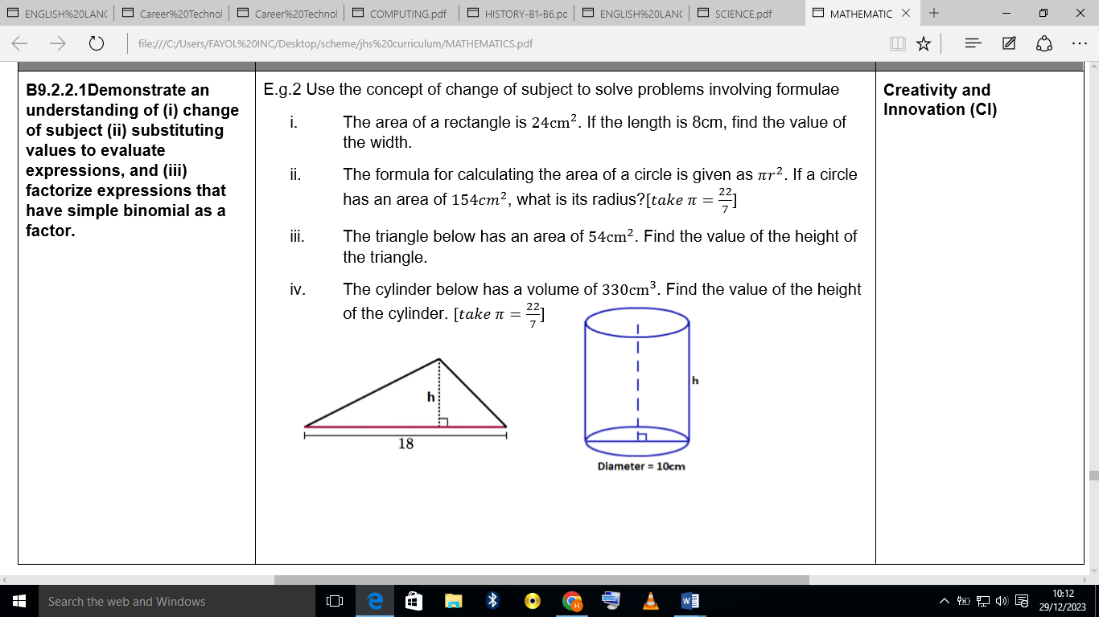  5) The cylinder below has a volume of 330cm³. Find the value of the height of the cylinder. [take 𝜋=22/7] |  |  |  |  | Counters, bundle and loose straws base ten cut square, Bundle of sticks
PHASE 3: REFLECTION | Use peer discussion and effective questioning to find out from learners what they have learnt during the lesson.  Take feedback from learners and summarize the lesson.

Week Ending: |  | DAY: |  | Subject: Mathematics
Duration: 60MINS |  |  |  | Strand: Algebra
Class: B9 |  | Class Size: |  | Sub Strand: Algebraic Expressions
Content Standard:  B9.2.2.1 Demonstrate an understanding of (i) change of subject (ii) substituting values to evaluate expressions, and (iii) factorize expressions that have simple binomial as a factor |  |  | Indicator:  B9.2.2.1.2 Substitute values into given formulae to evaluate it and use it to solve problems |  |  |  | Lesson:  1 of 1
Performance Indicator:  Learners can substitute values into formulas correctly to evaluate them and apply formula evaluation to solve problems in various contexts |  |  |  |  | Core Competencies:  Communication and Collaboration (CC) Critical Thinking and Problem solving (CP)
References: Mathematics Curriculum Pg. 182
New words:
Phase/Duration | Learners Activities |  |  |  |  | Resources
PHASE 1: STARTER | Engage learners with a fun superhero-themed warm-up activity (e.g., create superhero identities based on mathematical powers).  Review familiar formulas from previous lessons (e.g., area, perimeter, volume).  Discuss the role of variables and values within formulas.  Share performance indicators and introduce the lesson.
PHASE 2: NEW LEARNING | Introduce the concept of substituting values into formulas to unlock their secrets.  Provide a visual demonstration using a simple formula like area of a rectangle (A = l × w).  Emphasize the importance of matching variables with corresponding values.  Provide guided practice with various formulas, encouraging student participation:  - Area of a triangle (A = 1/2 × b × h)  - Perimeter of a square (P = 4s)  - Volume of a rectangular prism (V = l × w × h)  Incorporate student whiteboards for individual practice and formative assessment.  Present real-world scenarios requiring formula substitution and problem-solving:  - Determining the cost of painting a rectangular wall given its dimensions and paint price per square meter.  - Calculating the amount of fencing needed for a square garden.  - Finding the volume of a gift box to ensure a present fits.  Encourage learners to think critically, identify relevant formulas, and apply substitution skills.  Provide differentiated worksheets with problems of varying difficulty levels.  Allow learners to work independently, showcasing their formula-solving powers.  Offer support and feedback as needed.  Example 1: Find the value of (𝒙−𝒃)^{𝟐} –𝟑(𝒙−𝒃) 𝒊f 𝒙=𝟐 and 𝒃=−𝟓  Solution  (𝒙−𝒃)^{𝟐} –𝟑(𝒙−𝒃) 𝒊f 𝒙=𝟐 and 𝒃=−𝟓  = (2−-5)^{𝟐} –𝟑(2−-5)  = (7)^{𝟐} –𝟑(7)  = 49 – 21  = 28  Assessment  - Make 𝒌 the subject of the formula  $\frac{1}{n}$ = √( $\frac{k^{2}+a^{2}}{hg}$ )  If n = $\frac{1}{n}$ , a =3, h= 2, g= 32, find the value of k.  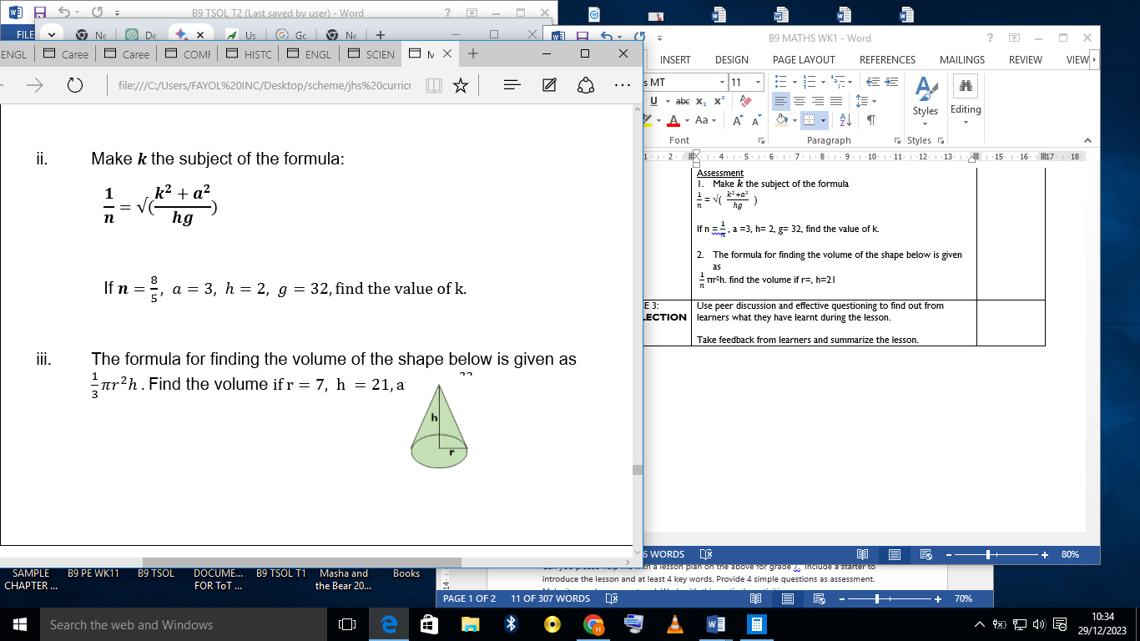  - The formula for finding the volume of the shape below is given as  $\frac{1}{n}$ πr²h. find the volume if r=, h=21 |  |  |  |  | Counters, bundle and loose straws base ten cut square, Bundle of sticks
PHASE 3: REFLECTION | Use peer discussion and effective questioning to find out from learners what they have learnt during the lesson.  Take feedback from learners and summarize the lesson.

