Fayol Inc. 0547824419
SECOND TERM
WEEKLY LESSON NOTES
WEEK 4
Week Ending: WEEK 4 |  | DAY: |  | Subject: Mathematics
Duration: 60MINS |  |  |  | Strand: Algebra
Class: B9 |  | Class Size: |  | Sub Strand: Patterns and Relations
Content Standard:  B9.2.1.1 Demonstrate the ability to construct tables of values for pairs of linear relations, graph the relations in a number plane and determine the intersection of the lines to solve simultaneous linear equations |  |  |  |  | Indicator:  B9.2.1.1.3 Use graphs to solve equations involving two linear relations |  | Lesson:  1 of 1
Performance Indicator:  Learners can identify the variables and coefficients in linear equations. |  |  | Core Competencies:  Communication and Collaboration (CC) Critical Thinking and Problem solving (CP)
References: Mathematics Curriculum Pg. 182
New words: graphs, equations, linear, relations
Phase/Duration | Learners Activities |  |  |  |  | Resources
PHASE 1: STARTER | Begin by discussing situations where two linear relations might intersect in real life (e.g., paths of two moving objects).  Connect the concept of intersections to solutions of systems of linear equations.  Share performance indicators and introduce the lesson.
PHASE 2: NEW LEARNING | Review the structure of linear equations (e.g., y= mx + b).  Identify variables, coefficients, and constants in sample linear equations.  Discuss the importance of having two equations to find a unique solution.  Demonstrate graphing linear equations on a coordinate plane.  Use simple examples and guide learners through plotting points and drawing lines.  Emphasize labeling axes, choosing appropriate scales, and representing equations visually.  Provide practice problems involving systems of linear equations.  Guide learners in graphing the equations and finding the point(s) of intersection.  Discuss different scenarios based on the number of intersections (one, none, or infinite solutions).  Present real-world problems that can be modeled with systems of linear equations.  Guide learners in translating problems into equations, graphing, and interpreting solutions.  Encourage discussions on the significance of intersection points in practical scenarios.  Distribute worksheets with problems of varying difficulty levels.  Allow learners to independently graph equations and find solutions. |  |  |  |  | Graphing paper or access to online graphing tools
PHASE 3: REFLECTION | Use peer discussion and effective questioning to find out from learners what they have learnt during the lesson.  Take feedback from learners and summarize the lesson.

Week Ending: WEEK 4 |  | DAY: | Subject: Mathematics
Duration: 60MINS |  |  | Strand: Algebra
Class: B9 |  | Class Size: | Sub Strand: Patterns and Relations
Content Standard:  B9.2.1.1 Demonstrate the ability to construct tables of values for pairs of linear relations, graph the relations in a number plane and determine the intersection of the lines to solve simultaneous linear equations |  |  |  | Indicator:  B9.2.1.1.3 Use graphs to solve equations involving two linear relations |  |  | Lesson:  1 of 1
Performance Indicator:  Learners can graph linear relations on a coordinate plane and interpret the coordinates of the intersection point as the solution to a system of equations. |  |  |  |  | Core Competencies:  Communication and Collaboration (CC) Critical Thinking and Problem solving (CP)
References: Mathematics Curriculum Pg. 182
New words: graphs, equations, linear, relations
Phase/Duration | Learners Activities |  |  |  |  | Resources
PHASE 1: STARTER | Display two graphs of linear relations intersecting at a single point.  Ask learners to describe what they see and what the point of intersection represents.  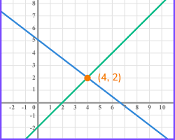  Share performance indicators and introduce the lesson.
PHASE 2: NEW LEARNING | Review the process of graphing linear equations using slope and y-intercept.  Emphasize that each point on a graph represents a solution to the equation.  Demonstrate how to check solutions by substituting coordinates into the equations.  Explain that the point where two graphs intersect represents a solution that satisfies both equations simultaneously.  Guide learners through examples to identify intersection points and interpret their coordinates as solutions.  Highlight that multiple intersection points indicate multiple solutions.  Discuss cases where graphs are parallel or coincident (infinite or no solutions).  Provide learners with pairs of linear equations and challenge them to:  - Graph each equation on the same coordinate plane.  - Identify the point of intersection (if it exists).  - State the solution as an ordered pair.  Check the solution by substituting into the equations.  Example 1: Solve the following equations simultaneously using a graph.  y = -x + 7  y = 2x + 1  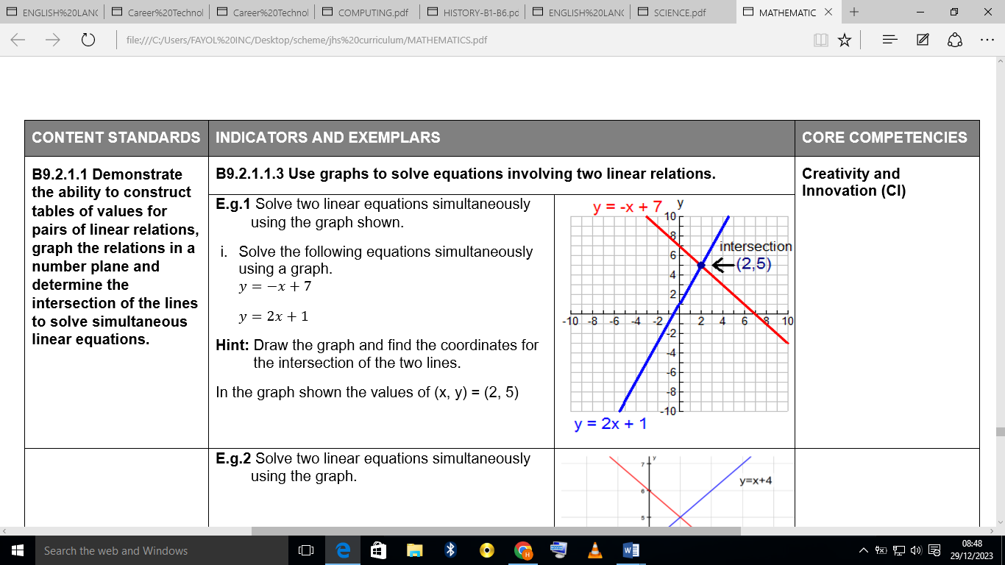  Hint: Draw the graph and find the coordinates for the intersection of the two lines  In the graph shown the values of (x, y) = (2, 5)  Assessment  Solve two linear equations simultaneously using the graph.  From the graph, determine the values of x and y that makes the linear equations true.  y = x + 4  y = 6 - x  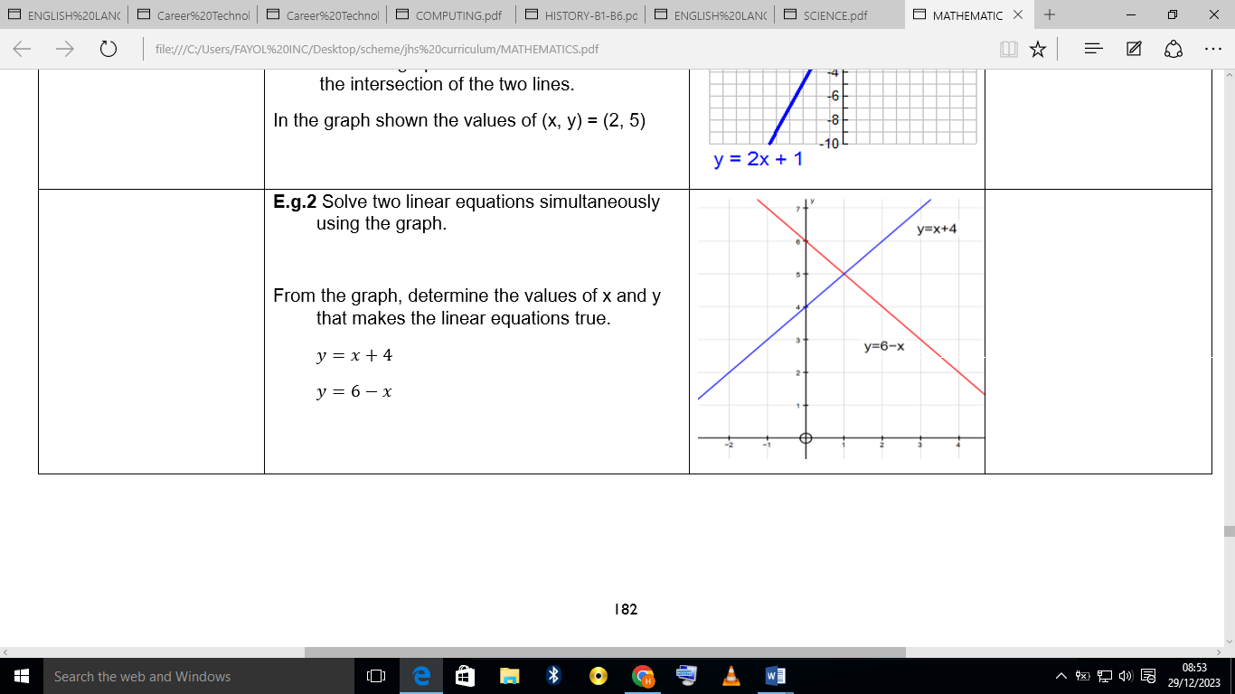 |  |  |  |  | Graph paper, Rulers
PHASE 3: REFLECTION | Use peer discussion and effective questioning to find out from learners what they have learnt during the lesson.  Take feedback from learners and summarize the lesson.

